**Project Title:**

**Assessment of Temporal and Spatial Variability of Water Stored in Sand Dams within the Shashi Catchment**

**Report Title:**

**Instrumentation Design And Installation Report**

June 2024

**Executive Summary**

**Overview of the Project**

The Nexus Gains research project aims to optimize trade-offs and build synergies to support SDG achievement through transformations in the food, land, and water systems nexus. Work Package 2 focuses on boosting water productivity and storage management, specifically targeting the water storage component of WP2, which aims to broaden traditional approaches to water storage and assess the performance of various storage options, including less conventional ones like sand dams. This project concept note outlines the assessment of sand dams in the Shashe Catchment of the Limpopo Basin, shared by Botswana and Zimbabwe, to enhance knowledge on their water storage capabilities and optimize their management with other storage options. The Instrumentation Design and Installation Report focuses on the design, fabrication, and installation of piezometers and water meters in the context of the Nexus Gains project. The project aims to enhance water productivity and storage management in the food, land, and water systems nexus. By implementing advanced monitoring techniques, the project seeks to optimize water use efficiency and support sustainable development goals.

**Purpose of the Report**

The primary objective of this report is to detail the techniques employed in designing piezometers, fabricating them, and installing them according to project specifications. Additionally, the report addresses the connection of water meters to Rowa Pumps for measuring water abstraction from sand rivers. By documenting these processes, the report aims to provide a comprehensive overview of the instrumentation design and installation procedures undertaken in the project. The Instrumentation Design and Installation Report delves into the meticulous process of designing, fabricating, and installing piezometers in alignment with the project specifications of the Nexus Gains initiative. The project operates within the framework of enhancing water productivity and storage management in the intricate nexus of food, land, and water systems. By implementing advanced monitoring techniques, the project aims to optimize water use efficiency and contribute to sustainable development goals in the project area.

The scope of this report encompasses a detailed exploration of the techniques employed in designing, fabricating, and installing piezometers according to the specific requirements of the Nexus Gains project. The report will provide a comprehensive overview of the steps involved in each stage of the process, including site selection, material selection, installation procedures, and data collection protocols. Additionally, the report will address the connection of water meters to rowa pumps and the significance of measuring water abstraction from sand rivers in the context of the project objectives. By documenting these processes, the report aims to contribute valuable insights into the instrumentation design and installation practices undertaken within the project.

**Objectives of the Instrumentation and Data Collection**

 The primary objectives of the instrumentation and data collection within the Nexus Gains project are multifaceted. Firstly, the project aims to design and install piezometers strategically to monitor water levels within the sand dams accurately. These piezometers play a crucial role in providing real-time data on water storage changes, enabling informed decision-making regarding water management practices. Secondly, the connection of water meters to rowa pumps facilitates the measurement of water abstraction from sand rivers, offering insights into water usage patterns and aiding in the calculation of water evaporation from the sand dams. Overall, the instrumentation and data collection processes are integral to the project's goal of enhancing water productivity and storage management in the project area.

**Site description**

**1.** **Tshaheyi Site Gwanda District, Ward 5**

Located in Dobota village, the Tshaheyi(Est. 2013) mature sand dam site is situated at coordinates -21.144528, 28.911163, and features a landscape dominated by a mixture of idwalas on the right bank and a clay soil on the left bank. I presents with significant sediment accumulation due to its location as trough for runoff from surrounding hilly ground, which facilitates effective water storage. The geological composition consists of sedimentary layers that have built up over years of sand dam operation. Hydrologically, the site has substantial water retention capacity, with a primary spillway height that indicates mature sediment levels. For site preparation and layout, the team marked out points for installing nine piezometers to cover the throwback section of the sand dam basin along the river length upstream of the sand dam wall, ensuring optimal placement for monitoring water levels.



**2. Tadla Site, Gwanda District, Ward 7:**

Located at coordinates -20.722174, 28.688646, the Tadla(Est. 2014) site is mature and easily accessible for Mapane village community water use. A diesel engine is used to draw water for Mapane Primary School, which has an enrollment of 287 students, and there is one Rowa pump available for community use. The geological characteristics of the site are mature and well-suited for water retention. During site preparation, the installation team marked out points spaced 20 meters apart, with the first point 6 meters from the dam wall. A probe was used to ensure that the scoop wells were not dug on top of boulders, thereby achieving the maximum possible depth for the piezometers.



**3. Mzingwane Site, Gwanda District, Ward 7:**

Positioned at coordinates -20.708219, 28.756200, the Mzingwane site located in Gqalaza village, features a sand dam basin, less than 200 meters in length. The site has one community Rowa pump drawing water from the dam. The geological profile includes rock formations just beyond the final piezometer point, which influences the site's water retention characteristics. For site preparation, the installation team marked out points spaced 20 meters apart, with the first point 6 meters from the dam wall. A probe was used to avoid boulders and ensure maximum depth for the piezometers.

**4. Nsimbi Site, Gwanda District, Ward 13:**

The Nsimbi site is located at coordinates -21.132452, 29.042099 in Nsimbi village, Ward 13. This site features a small, currently dry stream with a sand bed thickness averaging 1m , which presents unique challenges for water storage and retention. During site preparation, the installation team marked out points spaced 10-20 meters apart, with the first three piezometer locations set downstream of the dam to monitor downstream impact of sand dam construction. A probe was used to ensure that the scoop wells were not dug on top of boulders, thereby achieving the maximum possible depth for the piezometers.



**5. Zhokwe Mawane Site, Gwanda District, Ward 13:**

Located at coordinates -21.2025, 28.972456 along the Sengezane River, the Zhokwe Mawane site divides Mawane and Zhokwe villages. The site features a wide river channel, four Rowa pumps extracting water from the river, and one solarized irrigation garden. The geological and hydrological characteristics are conducive to water retention and community use. For site preparation, the installation team marked out points spaced 50 meters apart, with the first two piezometer locations set downstream of the dam. A probe was used to ensure that the scoop wells were not dug on top of boulders, thereby achieving the maximum possible depth for the piezometers.

1. **Nathi Site, Gwanda District, Ward 13:**

The Nathi sand dam(Est. 2020) (-21.254408; 28.981821) is located in Sifanjani villageon the Sengezane River, a tributary to the Thuli River. The site features one Rowa pump for community use and a large dam catchment area of 240km², which allows for substantial water storage. During site preparation, the team installed fifteen piezometers to cover the sand dam throwback and also to monitor the water level changes around the nearest rowa pumps installed upstream of the sand dam wallover a total span of 600 meters, with an average spacing of 20-30 meters. This layout ensures comprehensive monitoring of water levels and sediment accumulation.



**7. Pangamano Site, Gwanda District, Ward 13:**

The Pangamano site(Est. 2014) (-21.302228; 28.982980) located in Sifanjani/Nhlamba village features two non-functional Rowa pumps and a pump that draws water to a solar irrigation garden. The site's geological and hydrological characteristics are suitable for water retention and agricultural use. For site preparation, the team marked out points for piezometer installation, ensuring optimal placement for monitoring water levels and maintaining the integrity of the irrigation system.



**Instrumentation Design**

**Overview of Instrumentation Used:** The instrumentation utilized in this project encompasses a range of devices tailored for monitoring and measuring water-related parameters within sand rivers. Key instruments include piezometers, water meters, and Rowa Pumps. These tools are essential for assessing water levels, abstraction rates, and overall hydrological dynamics in the study sites. Piezometers provide data on hydraulic head variations within the sand dam system, while water meters and Rowa pumps facilitate accurate measurement and management of water extraction. This section details the design and selection criteria, the instrumentation used, and the methodologies employed for their installation.

**Design Criteria and Considerations:** In designing the instrumentation for this project, several critical criteria and considerations were taken into account to ensure optimal performance and data accuracy. Factors such as durability, accuracy, compatibility with the sand river environment, ease of maintenance, and data transmission capabilities were integral in the design process. The instruments were designed to withstand the harsh conditions of sand rivers while providing precise and reliable measurements.

**Selection of Instruments:**

**Piezometers**: Piezometers play a crucial role in measuring groundwater levels and pressures within sand dams. The selection of piezometers for this project was based on their ability to withstand the sandy environment, provide accurate readings, and facilitate easy data collection. Special attention was given to the design of the piezometers to ensure they are suitable for installation in sand river beds and can withstand potential sedimentation and clogging issues.

Piezometers are used to measure the pressure head at specific points within the sand dam. They consist of a perforated pipe that is installed vertically into the ground, allowing water to enter and rise to a level that corresponds to the hydraulic head at that point.

**Fabrication**:

1. **Materials**: High-density polyethylene (HDPE) pipes were chosen for their corrosion resistance, durability, and ease of installation.
2. **Perforations**: Pipes were perforated at regular intervals to allow for water entry, ensuring accurate reflection of the groundwater table.
3. **Filter Pack**: A filter pack consisting of gravel and geotextile fabric was placed around the piezometer to prevent clogging by fine sediments.

**Installation**:

1. **Site Selection**: Locations for piezometer installation were chosen based on hydrogeological surveys, ensuring representative sampling points upstream and downstream of the sand dam.
2. **Drilling**: Boreholes were drilled to the required depth using manual augers.
3. **Insertion**: Piezometers were inserted into the boreholes, ensuring vertical alignment and secure placement.
4. **Sealing**: The annular space around the piezometer was sealed with bentonite clay to prevent surface water infiltration, ensuring accurate measurements.

**Water Meters:** Water meters were chosen for their capability to accurately measure water abstraction rates from sand rivers. The selected water meters are designed to withstand the abrasive nature of sand particles and provide real-time data on water flow rates. These meters are essential for quantifying water usage and monitoring abstraction activities in the study sites. Water meters are essential for quantifying the volume of water abstracted from the sand dam, facilitating effective water resource management.

**Selection Criteria**:

1. **Accuracy and Reliability**: Selection of meters with high accuracy and reliability to ensure precise water usage records.
2. **Flow Range**: Meters capable of measuring a wide range of flow rates, accommodating variations in water demand.

**Installation**:

1. **Placement**: Water meters were installed at strategic points along the abstraction points, particularly at the outlets of Rowa pumps.
2. **Calibration**: Initial calibration was performed to ensure accuracy, with regular recalibration scheduled as part of the maintenance routine.

**Rowa Pumps:** Rowa Pumps were integrated into the instrumentation design to facilitate the measurement of water abstraction from sand rivers. These pumps are selected for their efficiency in extracting water from sand dams and their compatibility with the water meters for data collection. The Rowa Pumps are designed to operate reliably in sandy conditions and provide consistent water flow for accurate measurements.

**Selection Criteria**:

1. **Efficiency**: High efficiency to ensure optimal water abstraction with minimal energy use.
2. **Durability**: Robust construction to withstand continuous operation and exposure to environmental elements.
3. **Ease of Operation**: User-friendly design to enable easy operation by community members.

**Installation**:

1. **Positioning**: Pumps were installed at predefined abstraction points, ensuring optimal placement for efficient water extraction.
2. **Connection to Water Meters**: Pumps were connected to water meters to facilitate accurate measurement of abstracted water.
3. **Training**: Training sessions were conducted for community members on the operation and maintenance of the pumps.

By carefully selecting and designing the instrumentation components, including piezometers, water meters, and Rowa Pumps, this project ensures the collection of precise and reliable data on alluvial aquifer water level variations, water abstraction rates, and hydrological processes in sand rivers.

**Piezometer Configuration**

1. 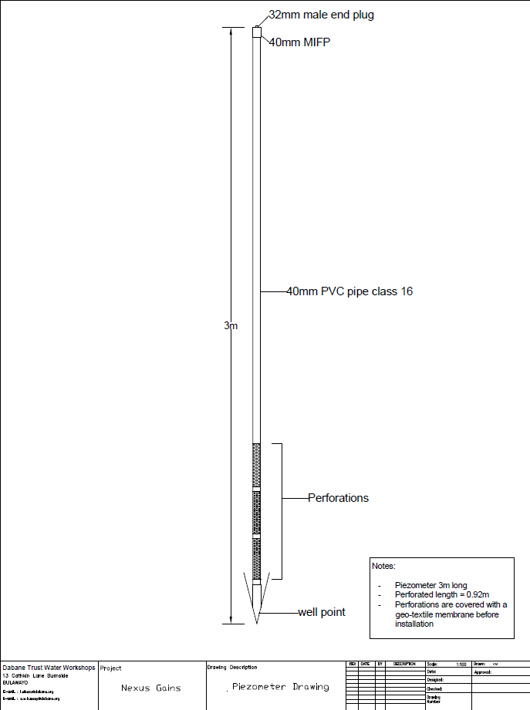Design specifications
2. **Installation locations and depths**
3. Mawane Zhokwe

|  |  |  |  |  |  |  |
| --- | --- | --- | --- | --- | --- | --- |
| **Piezometer Name** | **Initial Height (m)** | **Cut-off Height (m)** | **Final Height (m)** | **Distance upstream from Prop Sand Dam wall (m)** | **Co-Ordinates** | |
| **Latitude** | **Longitude** |
| P3 | 3.000 | 0.000 | 3.000 | 10 | -21.2034 | 28.972614 |
| P4 | 3.000 | 0.000 | 3.000 | 65 | -21.2029 | 28.972534 |
| P5 | 3.000 | 0.000 | 3.000 | 115 | -21.2025 | 28.972456 |
| P6 | 3.000 | 0.540 | 2.460 | 165 | -21.2021 | 28.972448 |
| P7 | 3.000 | 0.000 | 3.000 | 215 | -21.2016 | 28.972392 |
| P8 | 3.000 | 0.000 | 3.000 | 265 | -21.2012 | 28.97235 |
| P9 | 3.000 | 0.000 | 3.000 | 315 | -21.2007 | 28.97234 |
| P10 | 3.000 | 0.000 | 3.000 | 365 | -21.2003 | 28.972343 |
|  |  |  |  |  |  |  |
| **Piezometer Name** | **Initial Height (m)** | **Cut-off Height (m)** | **Final Height (m)** | **Distance downstream from Prop Sand Dam wall (m)** | **Co-Ordinates** | |
| **Latitude** | **Longitude** |
| P1 | 3.000 | 0.000 | 3.000 | 20 | -21.2037 | 28.972751 |
| P2 | 3.000 | 0.000 | 3.000 | 5 | -21.2036 | 28.972696 |

1. Nathi

|  |  |  |  |  |  |  |
| --- | --- | --- | --- | --- | --- | --- |
| **Piezometer Name** | **Initial Height (m)** | **Cut-off Height (m)** | **Final Height (m)** | **Distance upstream from Sand Dam wall (m)** | **Co-Ordinates** | |
| **Latitude** | **Longitude** |
| Pz 1 | 3 | 0.713 | 2.287 | 5 | -21.25444 | 28.98196 |
| Pz 2 | 3 | 1.568 | 1.432 | 5 | -21.25435 | 28.98187 |
| Pz 3 | 3 | 1.148 | 1.852 | 5 | -21.2543 | 28.98177 |
| Pz 4 | 3 | 1.57 | 1.43 | 25 | -21.25428 | 28.98207 |
| Pz 5 | 3 | 0.905 | 2.095 | 45 | -21.25418 | 28.98220 |
| Pz 6 | 3 | 0.541 | 2.459 | 65 | -21.2541 | 28.98233 |
| Pz 7 | 3 | 0.75 | 2.25 | 85 | -21.25401 | 28.98253 |
| Pz 8 | 3 | 0.982 | 2.018 | 105 | -21.254 | 28.98271 |
| Pz 9 | 3 | 1.153 | 1.847 | 140 | -21.2539 | 28.98302 |
| Pz 10 | 3 | 0.74 | 2.26 | 185 | -21.2538 | 28.98342 |
| Pz 11 | 3 | 1.19 | 1.81 | 215 | -21.25379 | 28.98383 |
| Pz 12 | 3 | 0.63 | 2.37 | 245 | -21.2538 | 28.98413 |
| Pz 13 | 3 | 0.945 | 2.055 | 405 | -21.25244 | 28.98445 |
| Pz 14 | 3 | 1.075 | 1.925 | 505 | -21.2515 | 28.98415 |
| Pz 15 | 3 | 0.986 | 2.014 | 605 | -21.25062 | 28.98395 |

1. Tshayeyi

|  |  |  |  |  |  |  |
| --- | --- | --- | --- | --- | --- | --- |
| **Piezometer Name** | **Initial Height (cm)** | **Cut-off Length (cm)** | **Final Length (cm)** | **Co-Ordinates** | | **Distance from sand dam (m)** |
| **Latitude** | **Longitude** |
| Pz 1 | 300 | 116.5 | 183.5 | 21.144506 S | 28.911113 E | 5 |
| Pz 2 | 300 | 160 | 140 | 21.144479 S | 28.911156 E | 5 |
| Pz 3 | 300 | 140 | 160 | 21.144394 S | 28.911028 E | 20 |
| Pz 4 | 300 | 152 | 148 | 21.144300 S | 28.910928 E | 35 |
| Pz 5 | 300 | 75 | 225 | 21.144186 S | 28.910840 E | 50 |
| Pz 6 | 300 | 65 | 235 | 21.144095 S | 28.91074 E | 65 |
| Pz 7 | 300 | 61 | 239 | 21.144092 S | 28.9107 E | 80 |
| Pz 8 | 300 | 110 | 190 | 21.1439 S | 28.9105 E | 95 |
| Pz 9 (muddy) | 300 | 94 | 206 | 21.1438 S | 28.9105 E | 110 |

1. Mpangamano

|  |  |  |  |  |  |  |
| --- | --- | --- | --- | --- | --- | --- |
| **Piezometer Name** | **Initial Height (m)** | **Cut-off Height (m)** | **Final Height (m)** | **Distance upstream from Sand Dam wall (m)** | **Co-Ordinates** | |
| **Latitude** | **Longitude** |
| P 1 | 3 | 1.19 | 2.287 | 5 | -21.3022 | 28.98296 |
| P 2 | 3 | 1.232 | 1.432 | 6.5 | -21.30219 | 28.98286 |
| P 3 | 3 | 0.953 | 1.852 | 4 | -21.3022 | 28.98275 |
| P 4 | 3 | 1.3 | 1.43 | 27 | -21.30201 | 28.98291 |
| P 5 | 3 | 1.058 | 2.095 | 47 | -21.30183 | 28.98293 |
| P 6 | 3 | 1.358 | 2.459 | 67 | -21.30167 | 28.98298 |
| P 7 | 3 | 1.22 | 2.25 | 87 | -21.30148 | 28.98295 |
| P 8 | 3 | 1.153 | 2.018 | 107 | -21.30129 | 28.98297 |
| P 9 | 3 | 1.498 | 1.847 | 150 | -21.30095 | 28.98333 |
| P 10 | 3 | 1.133 | 2.26 | 180 | -21.30067 | 28.98335 |
| P 11 | 3 | 1.211 | 1.81 | 210 | -21.3004 | 28.983338 |
| P 12 | 3 | 1.242 | 2.37 | 235 | -21.30016 | 28.98342 |
| P 13 | 3 | 1.22 | 2.055 | 290 | -21.29968 | 28.9835 |
| P 14 | 3 | 1.07 | 1.925 | 335 | -21.29927 | 28.98343 |
| P 15 | 3 | 1.215 | 2.014 | 405 | -21.2987 | 28.98312 |

1. Tadla

|  |  |  |  |  |  |  |
| --- | --- | --- | --- | --- | --- | --- |
| **Piezometer Name** | **Initial Height (m)** | **Cut-off Height (m)** | **Final Height (m)** | **Distance upstream from Sand Dam wall (m)** | **Co-Ordinates** | |
| **Latitude** | **Longitude** |
| P 1 | 3 | 0.626 | 2.374 | 6 | 20.72218 | -28.68869 |
| P 2 | 3 | 0.6 | 2.4 | 35 | 20.72194 | -28.68871 |
| P 3 | 3 | 0.642 | 2.358 | 45 | 20.72183 | -28.68871 |
| P 4 | 3 | 0.562 | 2.438 | 65 | 20.72165 | -28.68871 |
| P 5 | 3 | 1.02 | 1.98 | 85 | 20.72147 | -28.68869 |
| P 6 | 3 | 0.7 | 2.3 | 105 | 20.72128 | -28.68867 |
| P 7 | 3 | 1.013 | 1.987 | 115 | 20.7212 | -28.68864 |
| P 8 (upstream of bridge) | 3 | 1.153 | 1.847 | 135 | 20.72103 | -28.68858 |

1. Nsimbi

|  |  |  |  |  |  |  |
| --- | --- | --- | --- | --- | --- | --- |
| **Piezometer Name** | **Initial Height (m)** | **Cut-off Height (m)** | **Final Height (m)** | **Distance upstream from Sand Dam wall (m)** | **Co-Ordinates** | |
| **Latitude** | **Longitude** |
| P4 | 3 | 0.581 | 2.419 | 5 | -21.1324 | 29.042102 |
| P5 | 3 | 0.5 | 2.5 | 25 | -21.1322 | 29.042083 |
| P6 | 3 | 0.5 | 2.5 | 35 | -21.1321 | 29.042059 |
| P7 | 3 | 0.5 | 2.5 | 50 | -21.132 | 29.042069 |
| P8 | 3 | 0.5 | 2.5 | 67 | -21.1318 | 29.04206 |
| P9 | 3 | 0.5 | 2.5 | 85 | -21.1317 | 29.041995 |
| P10 | 3 | 1 | 2 | 95 | -21.1316 | 29.041918 |
|  | | | | | | |
| **Piezometer Name** | **Initial Height (m)** | **Cut-off Height (m)** | **Final Height (m)** | **Distance downstream from Prop Sand Dam wall (m)** | **Co-Ordinates** | |
| **Latitude** | **Longitude** |
| P1 | 3 | 1.631 | 1.369 | 30 | -21.1327 | 29.042123 |
| P2 | 3 | 1.52 | 1.48 | 20 | -21.1326 | 29.042107 |
| P3 | 3 | 1.412 | 1.588 | 10 | -21.1325 | 29.042085 |
|  |  |  |  |  |  |  |

1. uMzingwane

|  |  |  |  |  |  |  |
| --- | --- | --- | --- | --- | --- | --- |
| **Piezometer Name** | **Initial Height (m)** | **Cut-off Height (m)** | **Final Height (m)** | **Distance upstream from Sand Dam wall (m)** | **Co-Ordinates** | |
| **Latitude** | **Longitude** |
| P2 | 3 | 1.366 | 1.634 | 5 | -20.7082 | 28.75608 |
| P3 | 3 | 1.14 | 1.86 | 28 | -20.7082 | 28.75587 |
| P4 | 3 | 0.652 | 2.348 | 5 | -20.7082 | 28.7558 |
| P5 | 3 | 0.27 | 2.73 | 52 | -20.7082 | 28.75563 |
| P6 | 3 | 1.107 | 1.893 | 65 | -20.7082 | 28.75551 |
| P7 | 3 | 0.615 | 2.385 | 90 | -20.7081 | 28.75531 |
|  |  |  |  |  |  |  |
| **Piezometer Name** | **Initial Height (m)** | **Cut-off Height (m)** | **Final Height (m)** | **Distance downstream from Sand Dam wall (m)** | **Co-Ordinates** | |
| **Latitude** | **Longitude** |
| P1 (downstream) | 3 | 0.8 | 2.2 | 10 | -20.7082 | 28.75624 |

1. **Recording sheet and procedure for measuring water level inside the piezometer**

Step 1: Prepare the Piezometer

* Check the piezometer for any visible damage or obstructions. Ensure the top cap or cover is securely in place.
* Carefully remove the cap or cover from the top of the piezometer.

Step 3: Insert the Dip Stick

* Insert the dip stick gently into the piezometer all the way to the bottom.

Step 4: Withdrawing dip stick

* Carefully withdraw dip stick and lay it on the ground.

Step 5: Measure the Wetted Length:

* Measure the length of the wetted area using a tape measure

Step 6: Recording

* Record value of wetted length on the recording sheet shown below, clearly indicating piezometer it was obtained from and the time. Comment if theres anything on the state of the piezometer.

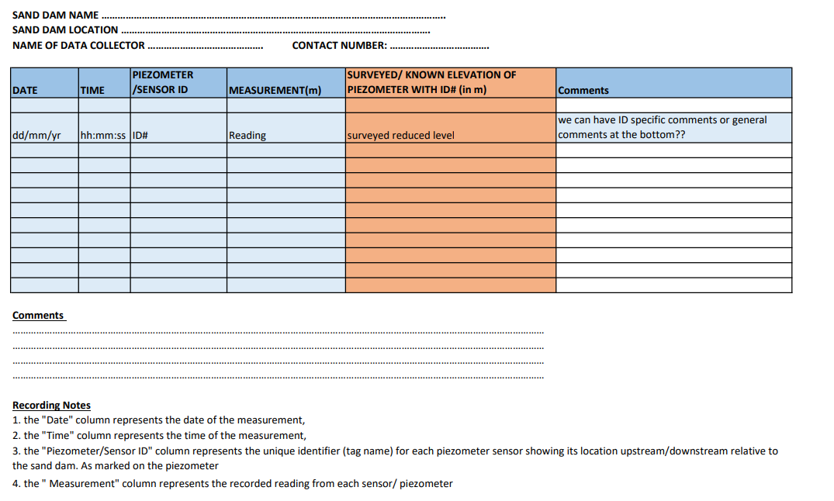

1. **Layout**

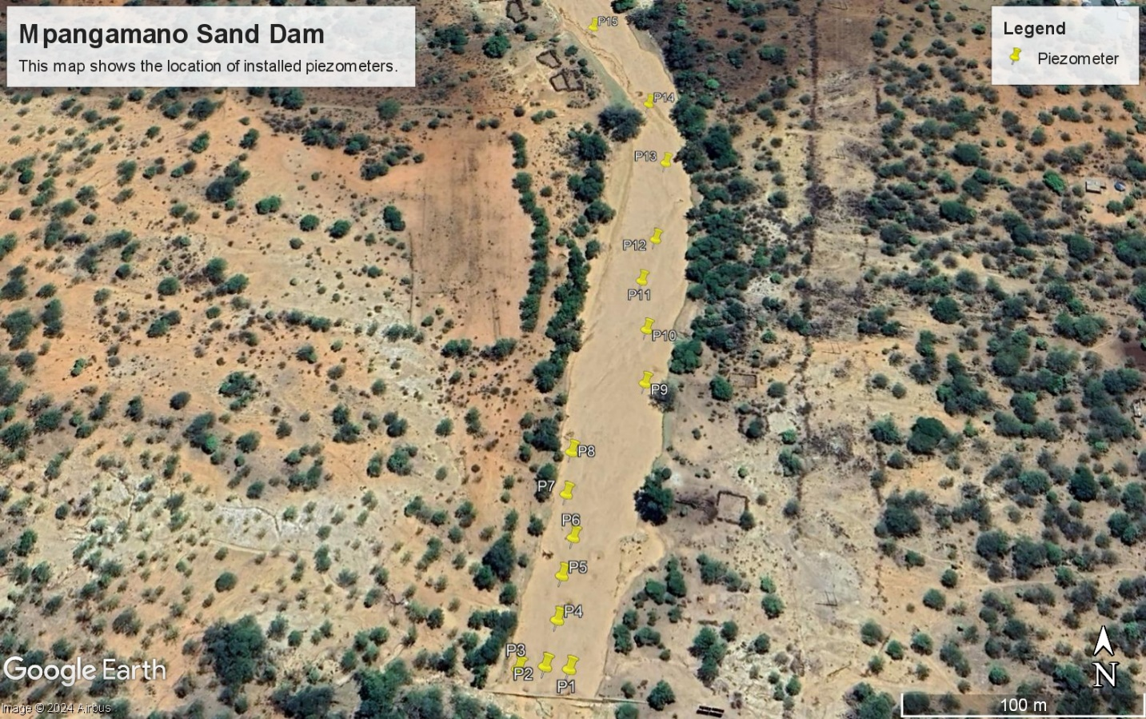

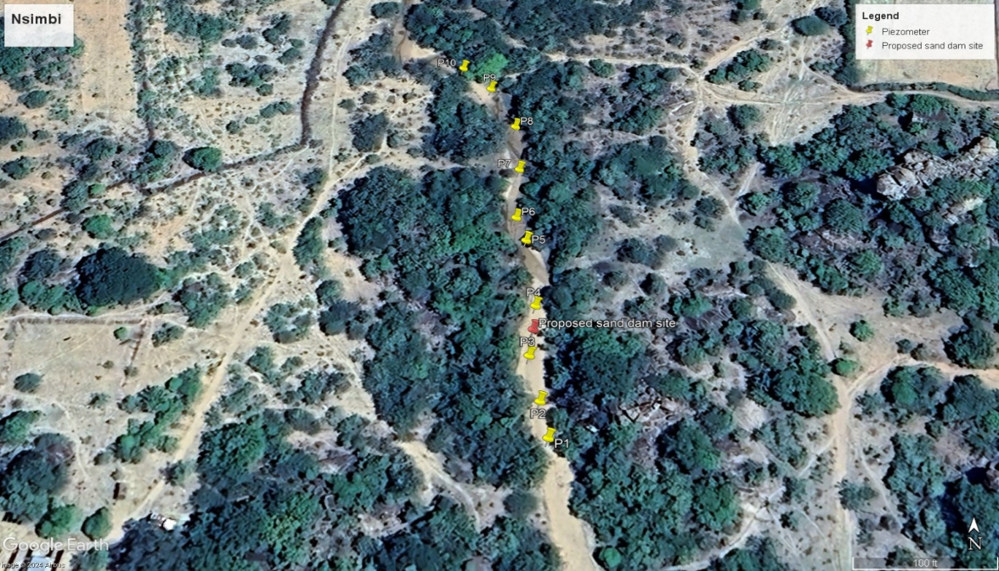

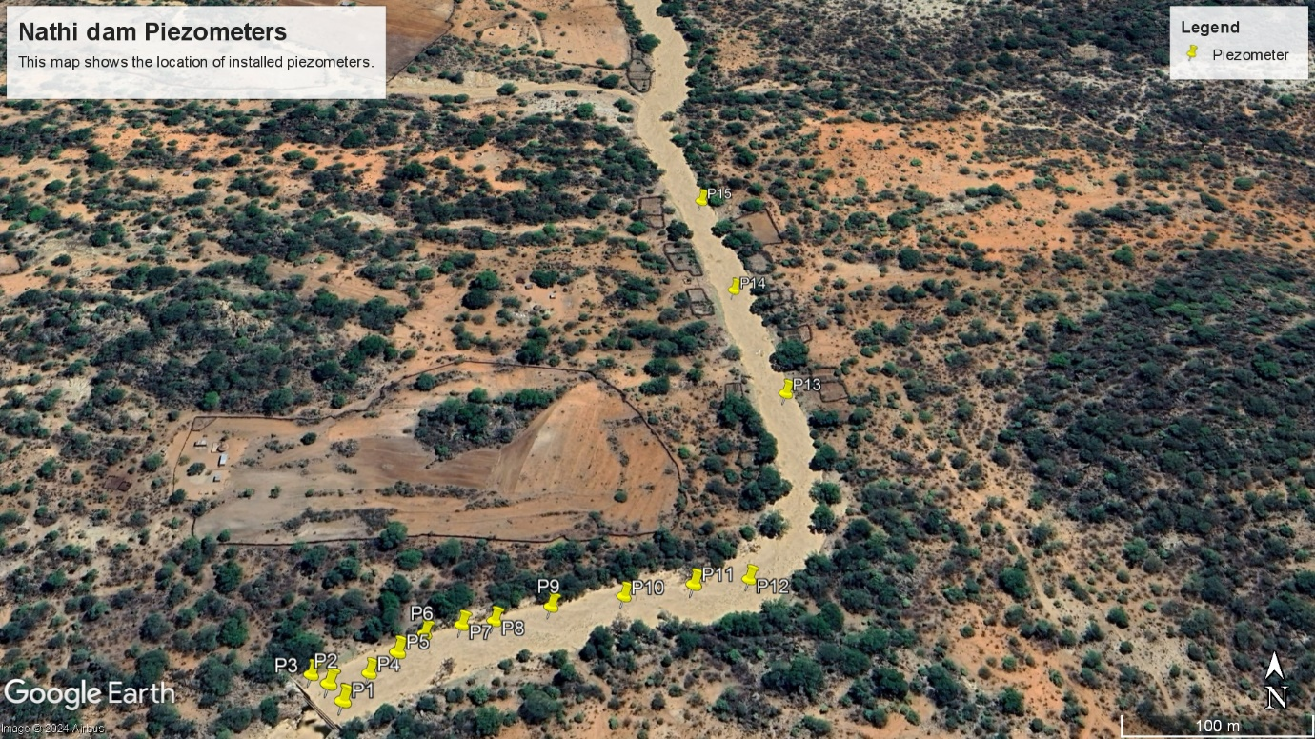

**Installation Methodology**

**The installation of piezometers involved the following steps:**

* Site Verification: Mature sand dam sites were verified to fit the criteria for piezometer installation.
* Digging Holes: Holes were dug to the river bed level for inserting the piezometers.
* Geotextile Cloth Covering: The perforations on the piezometers were covered using a geotextile cloth to prevent clogging by sediment.
* Auguring and Installation: Piezometers were augured into the pre-dug holes and buried, with about 30 cm left protruding above ground, which was then cut off.
* Marking and Data Recording: The piezometers were marked, and GPS coordinates were noted using DGPS. The height of the piezometers left above ground was also recorded .

**Sequence of Installation Activities**

* Piezometer Installation: This involved digging scoop wells, covering perforations, auguring the piezometers into place, marking, and noting GPS coordinates.
* Training of Field Monitors: Community members were trained to monitor the piezometers, emphasizing precise and consistent data collection .

**Challenges Encountered and Solutions Implemented**

* Physical Obstructions: At some sites like Pangamano, buried drums near the sand dam wall required adjustments in piezometer placement.
* Tool Resistance: The reinforced auguring tool was noted for its resistance to bending, indicating durability under tough conditions.
* Community Claims: At Tadla, community members reported a secondary wall under a bridge, affecting the storage dynamics, which required reconsideration of installation strategies .

**Quality Control and Assurance Measures**

* Accurate GPS Measurements: Coordinates were taken accurately using Thales DGPS equipment to ensure precise location tracking of piezometers.
* Probing Before Installation: Probes were used before and during installation to ensure piezometers reached sufficient depth.
* Training and Community Involvement: Field monitors selected by the community were trained on data collection and monitoring tasks to ensure ongoing quality and consistency in data recording .

These steps ensured the successful installation of piezometers, despite the challenges faced, and set a foundation for ongoing monitoring and data collection essential for the research on water stored in sand dams within the Shashi Catchment.

**Data Collection**

**Data Collection Methodology**

The methodology for data collection was designed to ensure accurate and reliable monitoring of groundwater levels and water abstraction from sand rivers. Piezometers were used to measure the hydraulic head at various points, while water meters connected to Rowa pumps measured the volume of water abstracted.

1. **Piezometers:**
   * Design: Piezometers were designed based on hydrogeological principles to ensure optimal placement and functionality. The design included considerations for depth, diameter, and screen length to accurately capture the hydraulic head data.
   * Fabrication: Piezometers were fabricated using high-quality PVC or stainless steel to withstand environmental conditions and prevent corrosion. The screen and riser pipes were assembled following precise specifications to ensure durability and accuracy.
   * Installation: Installation involved drilling boreholes at predetermined locations and depths, followed by the insertion of piezometers. Proper sealing around the annular space was ensured to prevent surface water contamination and to maintain the integrity of the measurements.
2. **Water Meters and Rowa Pumps:**
   * Design and Selection: Water meters were selected based on the expected flow rates and compatibility with Rowa pumps. The meters were designed to provide accurate measurements of water volume abstracted.
   * Installation: Water meters were installed inline with the discharge pipe of the Rowa pumps. Calibration was performed to ensure accuracy, and regular maintenance schedules were established to maintain performance.

**Frequency and Duration of Data Collection**

Data collection was structured to provide continuous and comprehensive monitoring.

* Frequency:
  + Groundwater levels were recorded hourly using automated data loggers attached to the piezometers.
  + Water abstraction volumes were recorded daily to capture the variations in water use.
* Duration:
  + The monitoring program was designed to last for a minimum of one hydrological year (12 months) to capture seasonal variations and provide robust data for analysis.
  + Periodic assessments were scheduled to evaluate the performance of the instrumentation and the need for recalibration or maintenance.

**Data Storage and Management**

Efficient data storage and management are critical for the integrity and usability of the collected data.

* Data Storage:
  + Data from piezometers and water meters were logged using digital data loggers. These loggers were connected to a central data management system via telemetry for real-time data transfer.
  + Redundant storage systems were used, including local storage on the devices and backup storage on cloud servers, to prevent data loss.
* Data Management:
  + A structured database was created to store and manage the data. This database allowed for easy retrieval, processing, and analysis.
  + Regular data validation procedures were implemented to ensure the accuracy and reliability of the data. This included cross-referencing with manual readings and conducting periodic calibration checks.
  + Data access protocols were established to control who could view and modify the data, ensuring data security and integrity.

**Initial Observations and Trends**

Initial data analysis revealed several key trends and observations:

* Groundwater Levels:
  + Seasonal fluctuations were observed in groundwater levels, with higher levels during the rainy season and lower levels during the dry season.
  + Certain areas exhibited significant drawdown, indicating high levels of water abstraction.
* Water Abstraction:
  + Daily water abstraction data showed a consistent pattern of usage, with peak abstraction periods corresponding to agricultural irrigation schedules.
  + The efficiency of Rowa pumps and the accuracy of water meters were confirmed through calibration checks, with negligible discrepancies observed.

These initial observations provided valuable insights into the hydrological behavior of the sand rivers and the effectiveness of the water management strategies implemented.